MULTI EMAILING DEBTORS OUTSTANDING

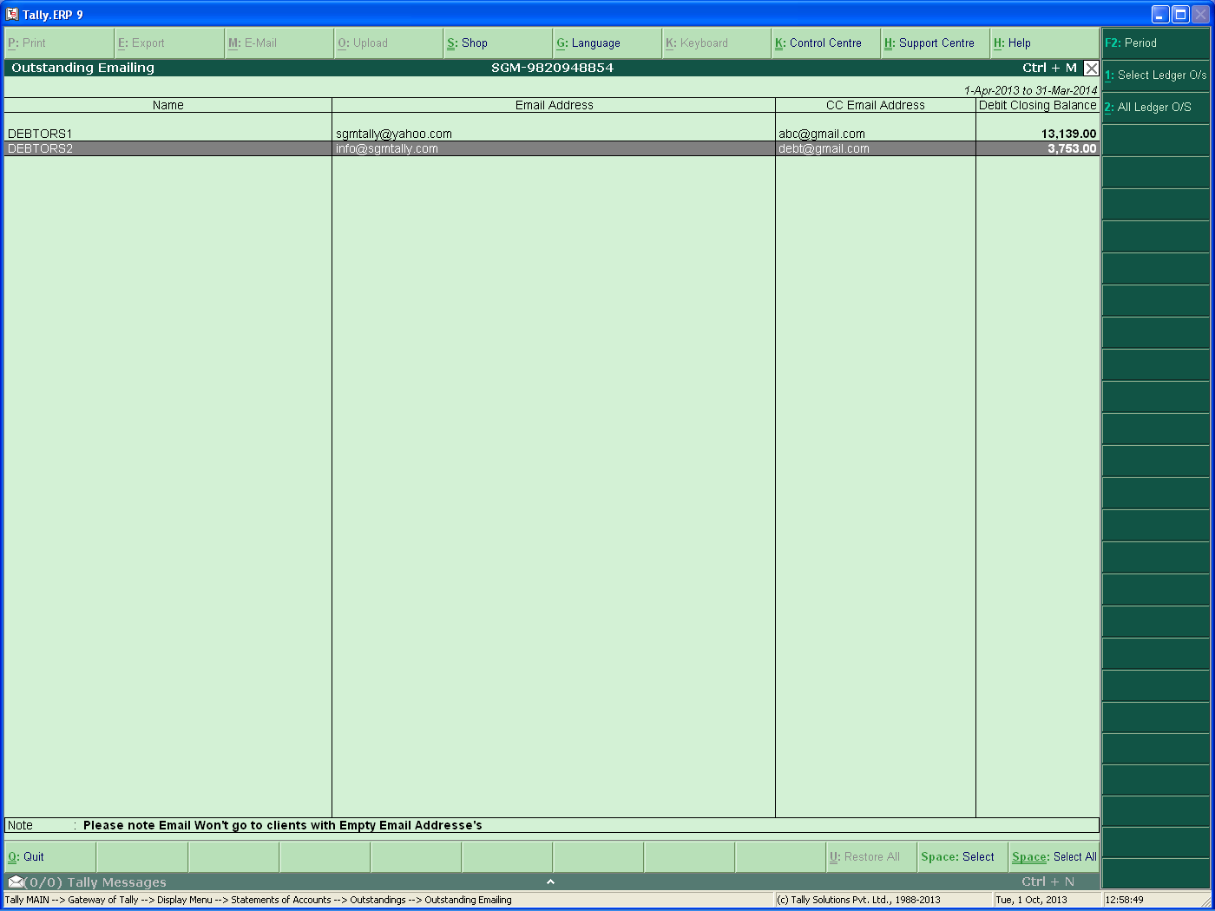
THREE BUTTONS BEEN PROVIDED
- PERIOD: AS PER THE PERIOD SELECTED THE OUTSTANDING DAYS WILL BE CALCULATED.BY DEFAULT IT WILL BE LAST VOUCHER DATE ENTRY
- SELECTED LEDGER OUTSTANDING EMAIL: USER CAN SELECT THE LEDGER’S BY SPACE KEY AND ONLY THE SELECTED LEDGER EMAIL WILL GO.
- ALL LEDGER OUTSTANDING EMAIL: THE USER CAN JUST CLICK ON THE BUTTON AND ALL LEDGER’S HAVING EMAIL ADDRESS THE OUTSTANDING STATEMENT WILL GO

